Mount:
Rider:

Owner of Mount: Jessy Wojtkiewicz Mount’s Name:
Contact Number: (513)623-9164 Age: Sex: G Height:
Temp: Pulse: Resp:
Farrier: Markings:
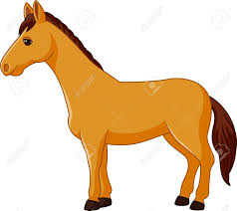
Contact Number:
Stable Vices: Allergies:
Veterinarian: Dr. Brian McNabb
Contact Number: (513)383-3832

 | AM | PM
Hay | 10lbs Timothy Orchard Grass Hay | 10lbs Timothy Orchard Grass Hay
Grain

